
Sri Lanka Institute of Information Technology

IT3012: Intelligent Agents – Lab 2
Y3.S1.WD.AI.01.01
Malabe Campus

Student ID - | IT24100140
Student Name - | Prathiban HTP
Module Name - | Intelligent Agents
Module Number - | IT3012
Lab Sheet Number - | 2
Lab Sheet Date - | 2026/July/31

Step 1.1
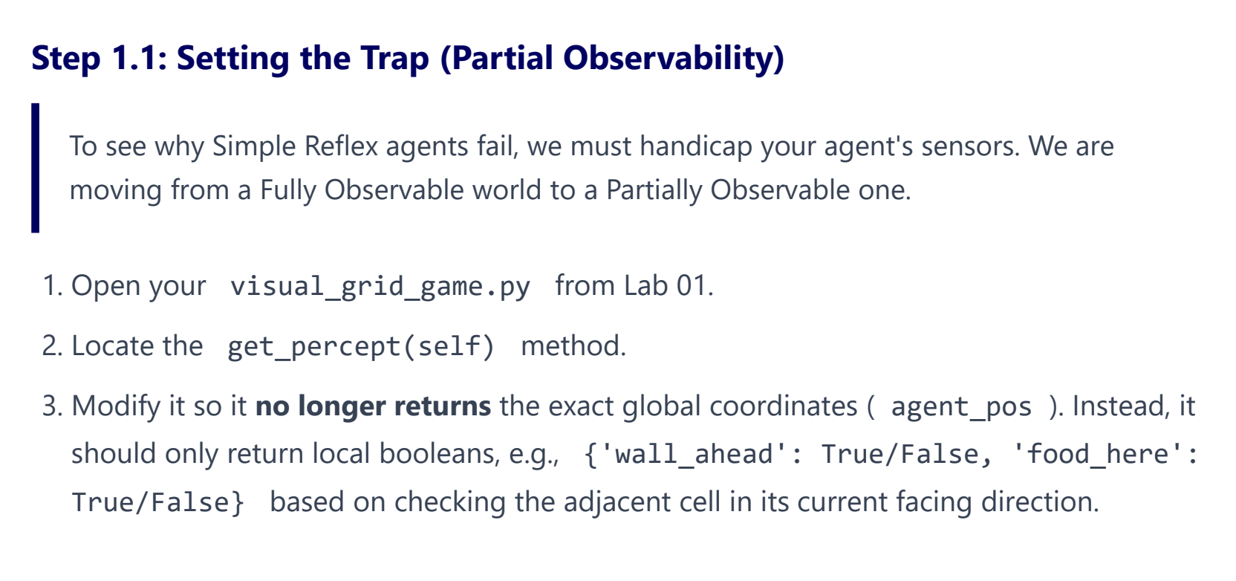
Previous get_percept fucntion
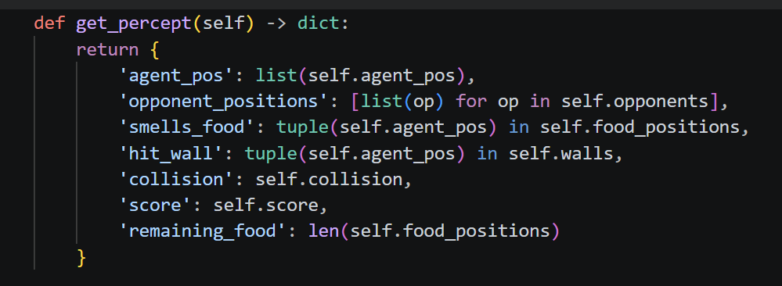
Updated get_percept function
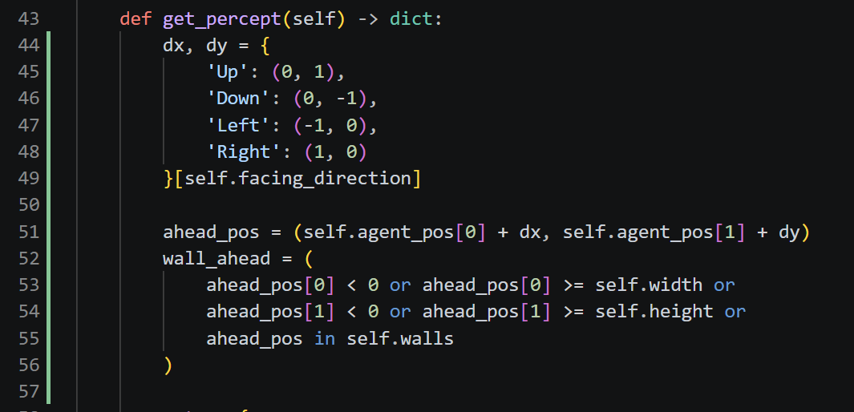

Step 1.2
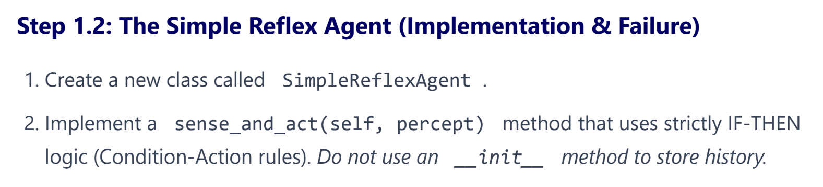
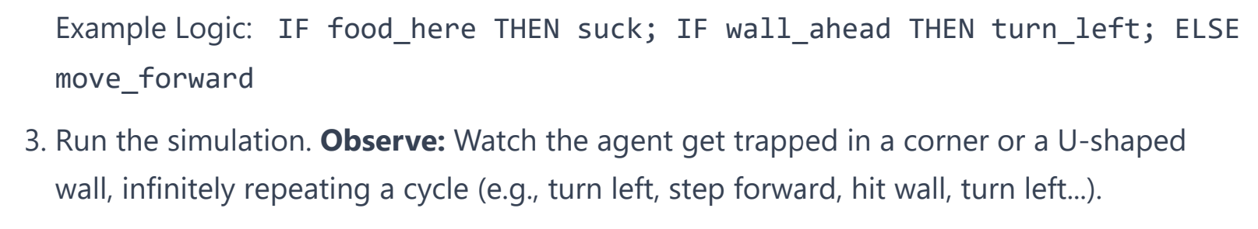
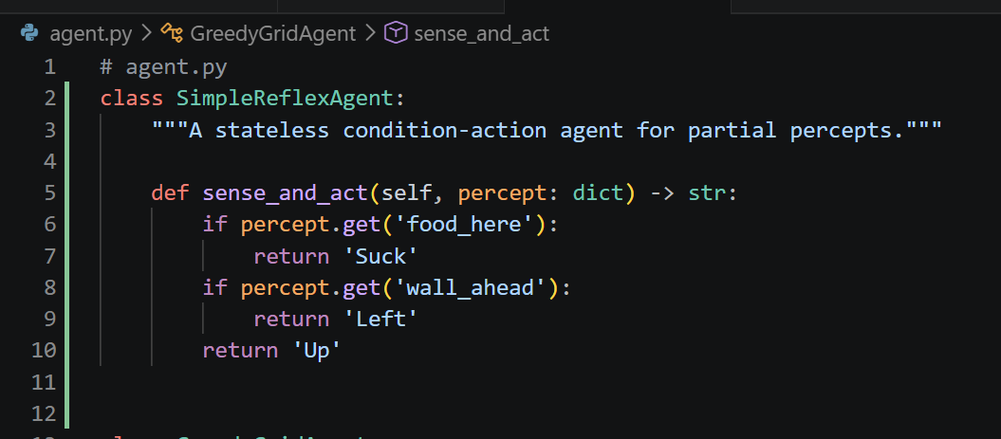

Step 1.3
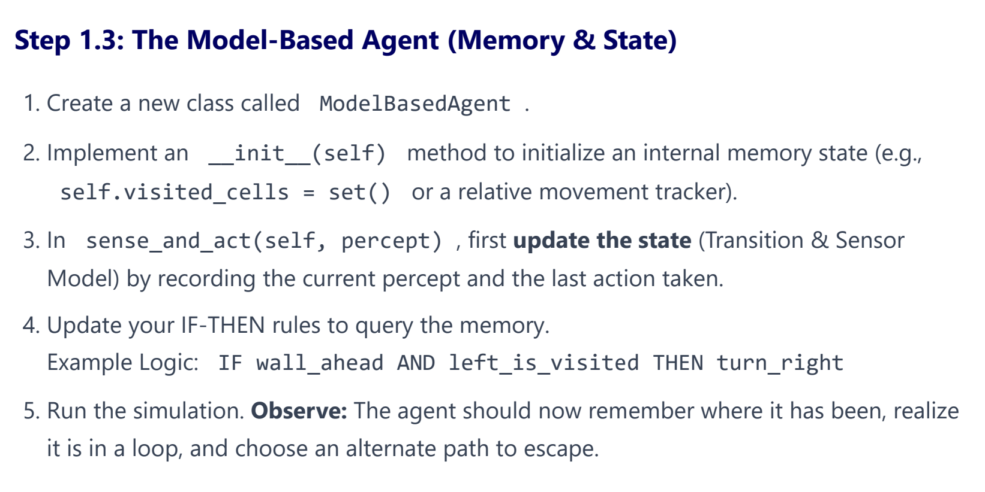
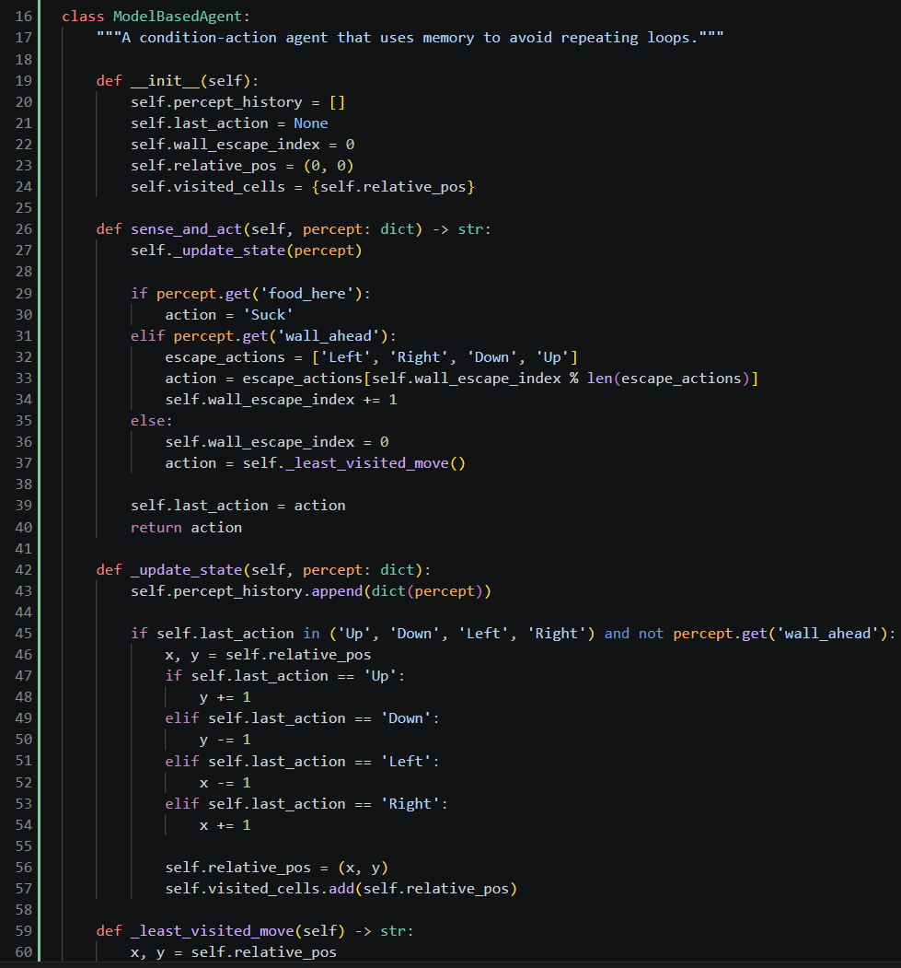

Task 2
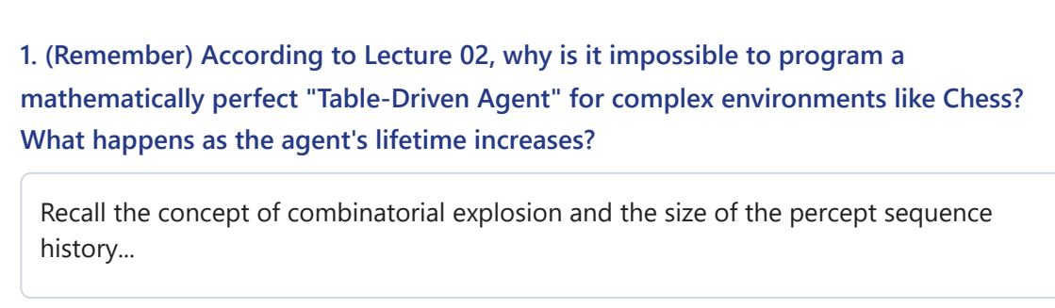
A Table-Driven Agent must store an action for every possible percept sequence. In complex environments like Chess, the number of percept sequences grows exponentially (combinatorial explosion), making the required table impossibly large. As the agent's lifetime increases, the percept history grows longer, requiring even more memory and computation.
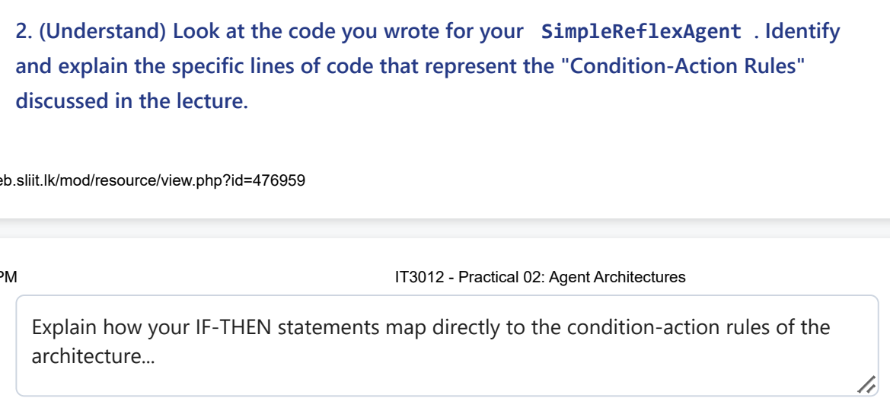
The condition-action rules are the if, elif, and else statements. Each rule checks the current percept and immediately selects an action (e.g., IF dirty → THEN suck). The agent does not use memory or percept history.
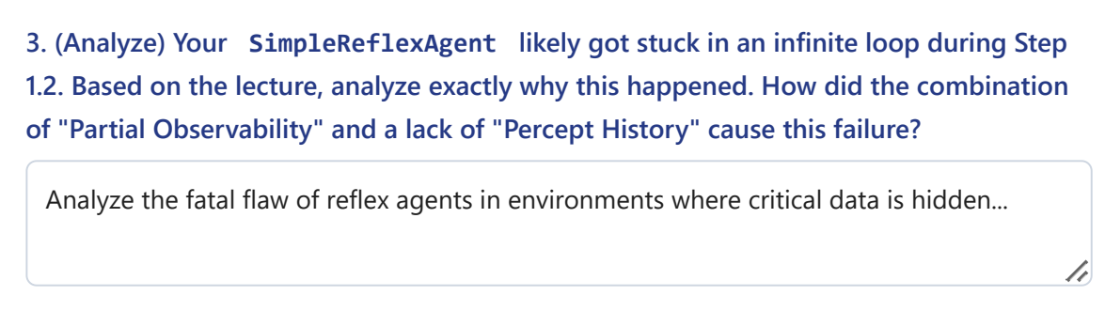
The environment was partially observable, and the agent had no percept history or internal memory. It could only react to the current percept, so it repeatedly executed the same actions (e.g., moving between two clean locations) without realizing the task was already complete.

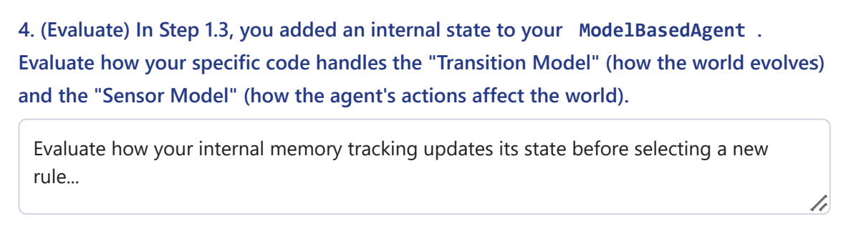
The ModelBasedAgent updates its internal state using new percepts (sensor model) and predicts how its previous actions changed the environment (transition model). This memory allows it to make better decisions and avoid the infinite loop experienced by the SimpleReflexAgent.

